­­­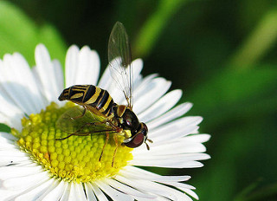

Flower Recognition

Statement of work

Rui Tang | Step I

# Abstract

This Statement will show the outlines of flower recognition system, which can detect flower type in a picture and label it correctly.

# Problem Statement

Our team wants to develop an augmented reality glasses. The glasses can automatically identify items in life and mark them. As part of the function, we hope that this automatic identification system can correctly identify the type of flower.

# Data Requirement

As we mentioned above, we need a bunch of flower pictures with labels. Fortunately, we found the right data on Kaggle. There are 5 types of flowers and our team has initially processed the data.

# Algorithm

As a visual recognition system, we expect to use Convolutional neural network with TensorFlow.

A convolutional neural network consists of an input and an output layer, as well as multiple hidden layers. The hidden layers of a CNN typically consist of a series of convolutional layers that convolve with a multiplication or other dot product. The activation function is commonly a RELU layer, and is subsequently followed by additional convolutions such as pooling layers, fully connected layers and normalization layers, referred to as hidden layers because their inputs and outputs are masked by the activation function and final convolution.[1]

In this system, inputs are pixels in each picture, and the output will be the probability of each category. Loss evaluation function will be Categorical Cross entropy.

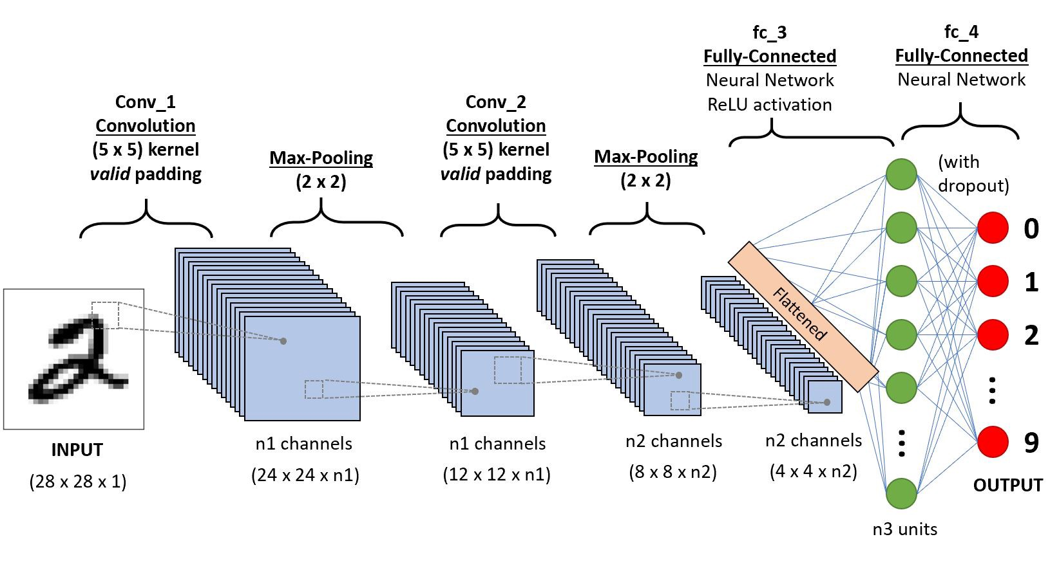

# Validation Process and Optimization

To avoid overfitting or underfitting, cross validation will be used. Firstly, we will split data into training set and test set randomly. After each epoch of training, the model will output the accuracy of both training set and test set.

After training, a curve diagram will be showed to indicate whether the model is overfitting or underfitting.

# Resources

<https://www.kaggle.com/alxmamaev/flowers-recognition>

1. <https://en.wikipedia.org/wiki/Convolutional_neural_network>